**IB Math SL Functions Review**

1. Which of the following relations are functions? Why or why not?

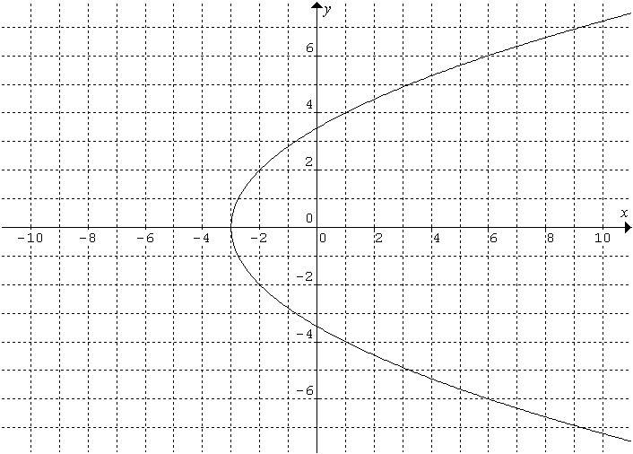(a)  (b)

(c) Domain Range

*f*

-2

5

11

-8

5

2. Find the implied domain of the given function.

(a)  (b)  (c) .

(d)  e)  f) 

3. Find the range of each function.

a)  b) 

4. Given, find the value(s) of *x* for which.

5. Given the function 

1. Write the function in the form 
2. Find the vertex
3. Find the x and y-intercepts

6. Find the value of *m* so that  has no real solutions.

7. A parabola has the equation. Find the coordinates of the *x*-intercepts and the vertex.

8. A ball is thrown vertically upwards into the air. The height *h* metres, of the ball above the ground after *t* seconds is given by .

* 1. Find the initial height of the ball above the ground (that is, at the moment it is released).
  2. Show that the height of the ball after one second is 17 metres
  3. At a later time the ball is again at a height of 17 metres.
     1. Write down an equation that *t* must satisfy when the ball is at a height of 17 metres.
     2. Solve the equation.

9. Given that  has axis of symmetry *x* = 3 and that (5, -1) and (0,-11) satisfy the equation, find the values of *a, b*, and *c*.

**Answers**:

1. a) yes, each x value has only 1 y-value.

b) no, does not pass the vertical line test.

c) yes, each value in the domain has only

one image.

2. a) 

b) 

c) 

d) 

e) 

f) 

3. a) 

b) 

4. 

5. a) 

b) 

c) no x-intercepts (),

y-intercept = 22

6. 

7. The x intercepts: (-1, 0), (7, 0)

The vertex: (3, 16)

8. (a) When , h is 2 meters

* 1. When , h is 17 meters
  2. 
  3.  or 

9. , , 

**Functions Review**

1. ,

a) Sketch the graph of,

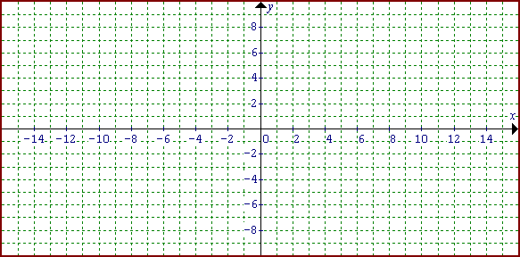

b) Sketch  c) Sketch 

2.  Sketch the graph of g



1. Given that 
   1. Find and 
   2. 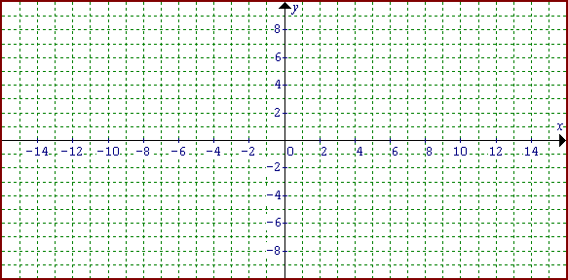Sketch the graph of  , clearly identifying the equations of all asymptotes and intercepts with the axes.

* 1. Evaluate 
  2. Find the value of x where f does not exist.



* 1. Sketch 

What is its domain?



* 1. Sketch 

What is its range?

**IB SL 1 Functions Review**

Show all necessary working. Calculators can be used.

1. For the functions  and 
   1. Explain why they are not identical functions
   2. Find the range of *g(x)*
2. Consider the function 
   1. What is the implied domain of *f* ?

On each of the axes below is a graph of *f*.

* 1. 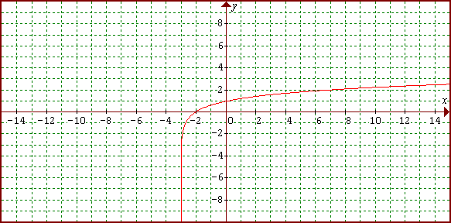Sketch 
  2. Sketch , clearly indicating the y-intercept.

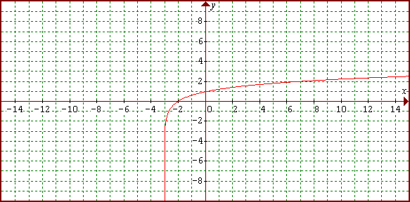

d) What is the equation of the vertical asymptote of *g*?

1. For the function ,
   1. Evaluate *g*(2)
   2. Find the value of *x* where *g* does not exist
   3. Find *g*(*x*+2) in simplest form
   4. Find *x* if **
2. Find constants *a* and *b* where  and *f*(1) = 1 and *f*(2) = 5.
3. Sketch the graph of  and  on the axes below.

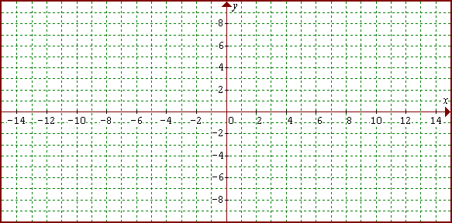

* 1. State the domain and range for *g*.
  2. Solve , giving your answer to 3 significant figures. (Use your calculator)